# **User documentation for Plant Planet**

## **Introduction**

Welcome to **Plant Planet** — your one-stop destination for discovering and caring for beautiful indoor plants. This user manual provides a step-by-step guide to help you navigate the website, manage your account, purchase plants, and explore our personalized subscription plans.

This guide is intended for customers and assumes no technical background. It covers all main features and sections of the site, along with helpful tips and visual guidance.

## **Getting Started**

### **Accessing the Website**

Plant Planet is accessible through any modern web browser on both desktop and mobile devices. No installation is required.

### **Creating an Account**

To purchase plants or subscribe to a plan, you must first register for an account. You can create an account by clicking the **"Profile"** icon in the navigation bar and selecting the **Sign Up** option. You’ll be asked to provide basic details such as your name, email address, and password.

## **Website Navigation**

Each page includes a responsive **navigation bar** (which becomes a drawer on mobile) and a **footer** with links to social media, privacy policy, and terms and conditions.

### **Key Pages:**

#### **Home Page(/)**

* View a curated list of all available plants.
* Apply filters based on **Light**, **Water needs**, **Temperature** and more.
* Use the **search bar** to find specific plants.
* Click on any plant to view detailed information or add it directly to your cart.  
  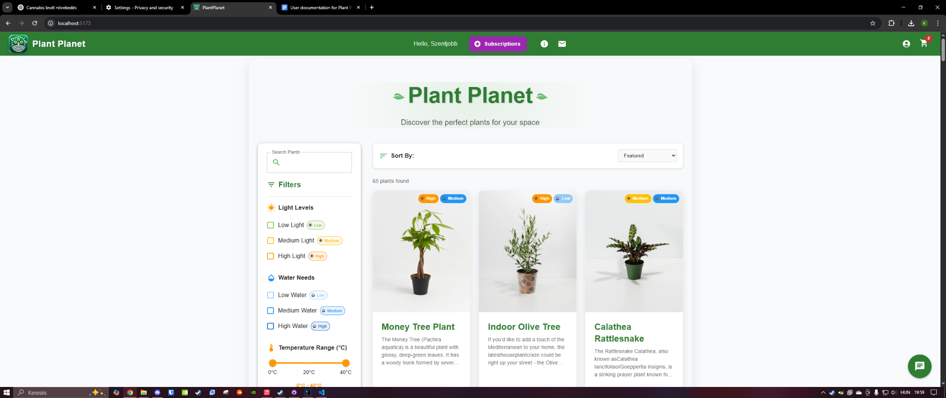

#### **Plant Details Page (/plant/{id})**

Shows in-depth information about a selected plant:

* + Light
  + Water
  + Humidity
  + Temperature
  + Fertilizing
  + Re-potting
  + Cleaning
  + Propagation

Add a custom quantity of the plant to your cart.

Includes a **long description**, **user reviews**, and an **"Explore More"** section.

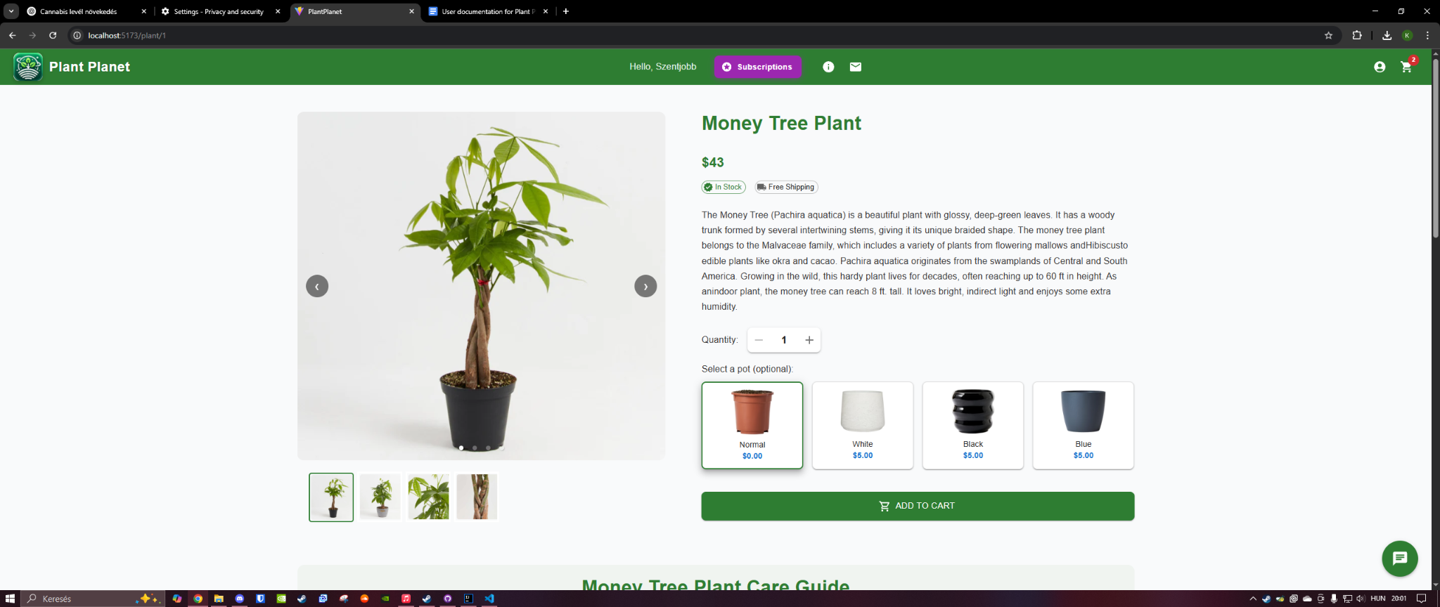

#### **Subscriptions Page(/subscriptions)**

* Browse unique subscription plans:  
  + **Mystery Plant Box** – receive a surprise plant quarterly.
  + **Plant Care Guru** – receive personalized monthly care emails and a free pot when a plant’s re-potting period arrives.

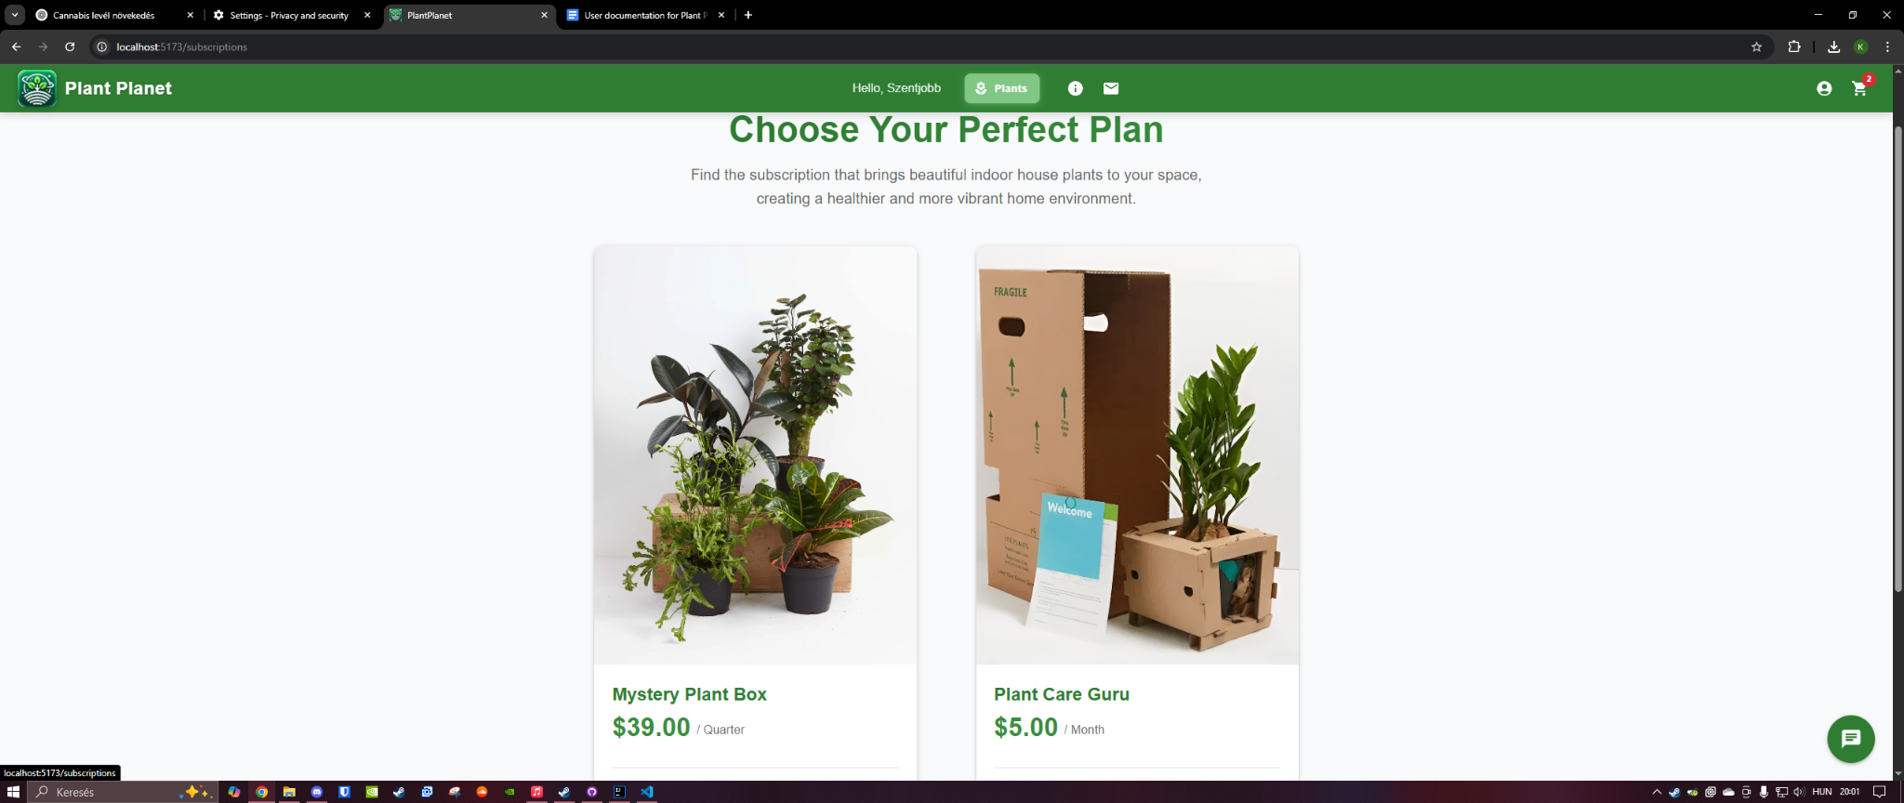

#### **Subscription Details Page (/subscriptions/{id})**

* Similar layout to the plant details page, with full descriptions of the subscription benefits and a subscription option.  
  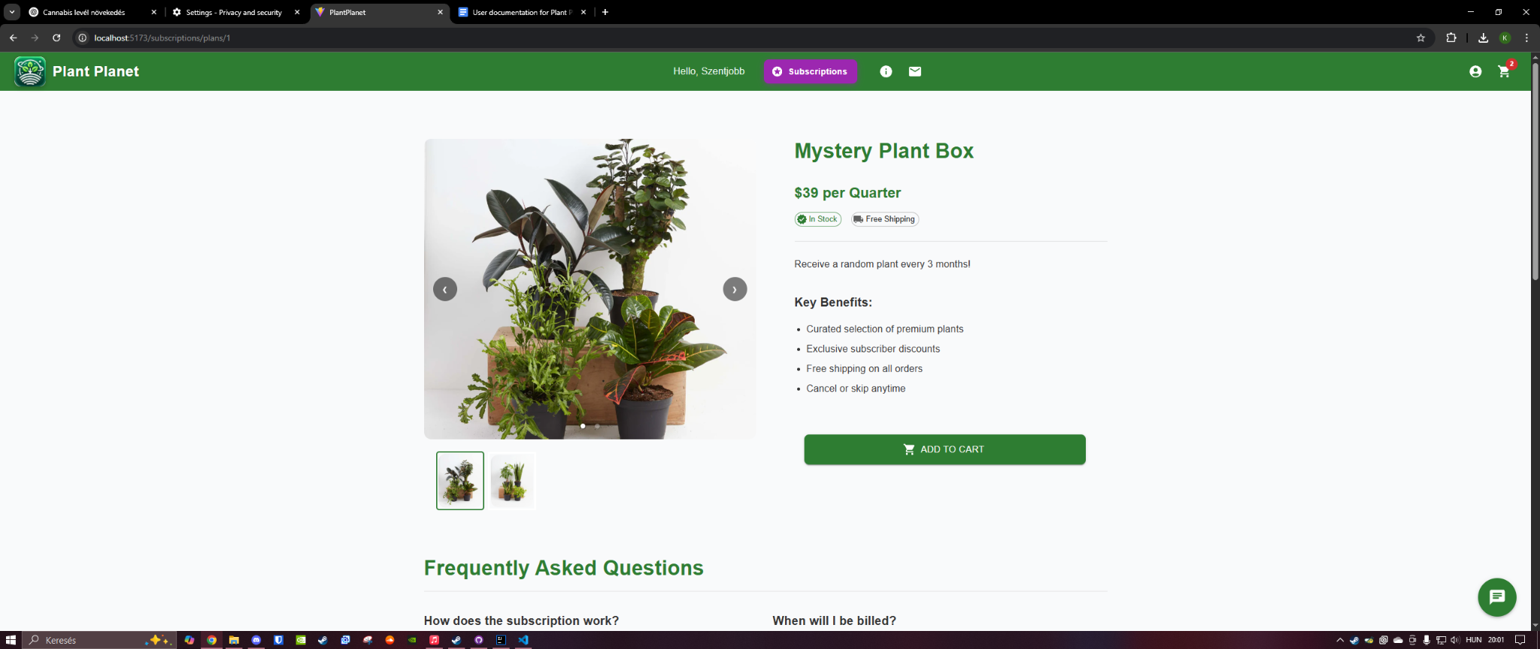

#### **Cart Page(/cart/view)**

* View all items added to your cart.
* Adjust quantities or remove items before proceeding to checkout.  
  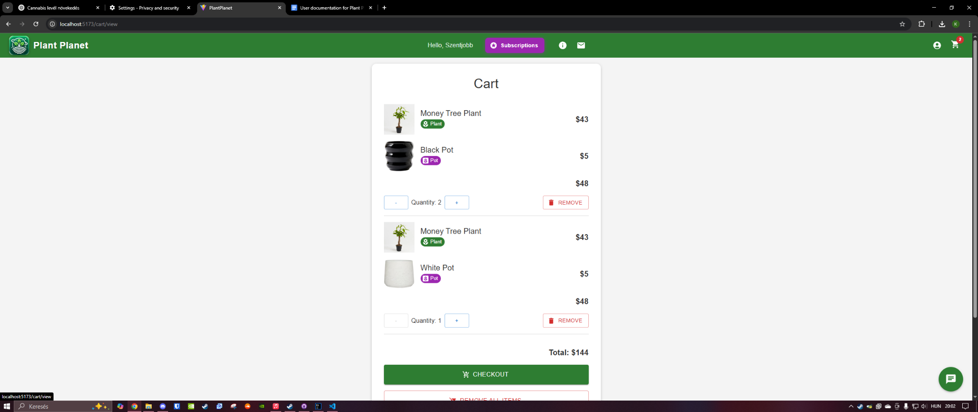

#### **Checkout Page(/checkout)**

* Provide shipping details (name, address, phone number).
* Finalize and place your order.  
  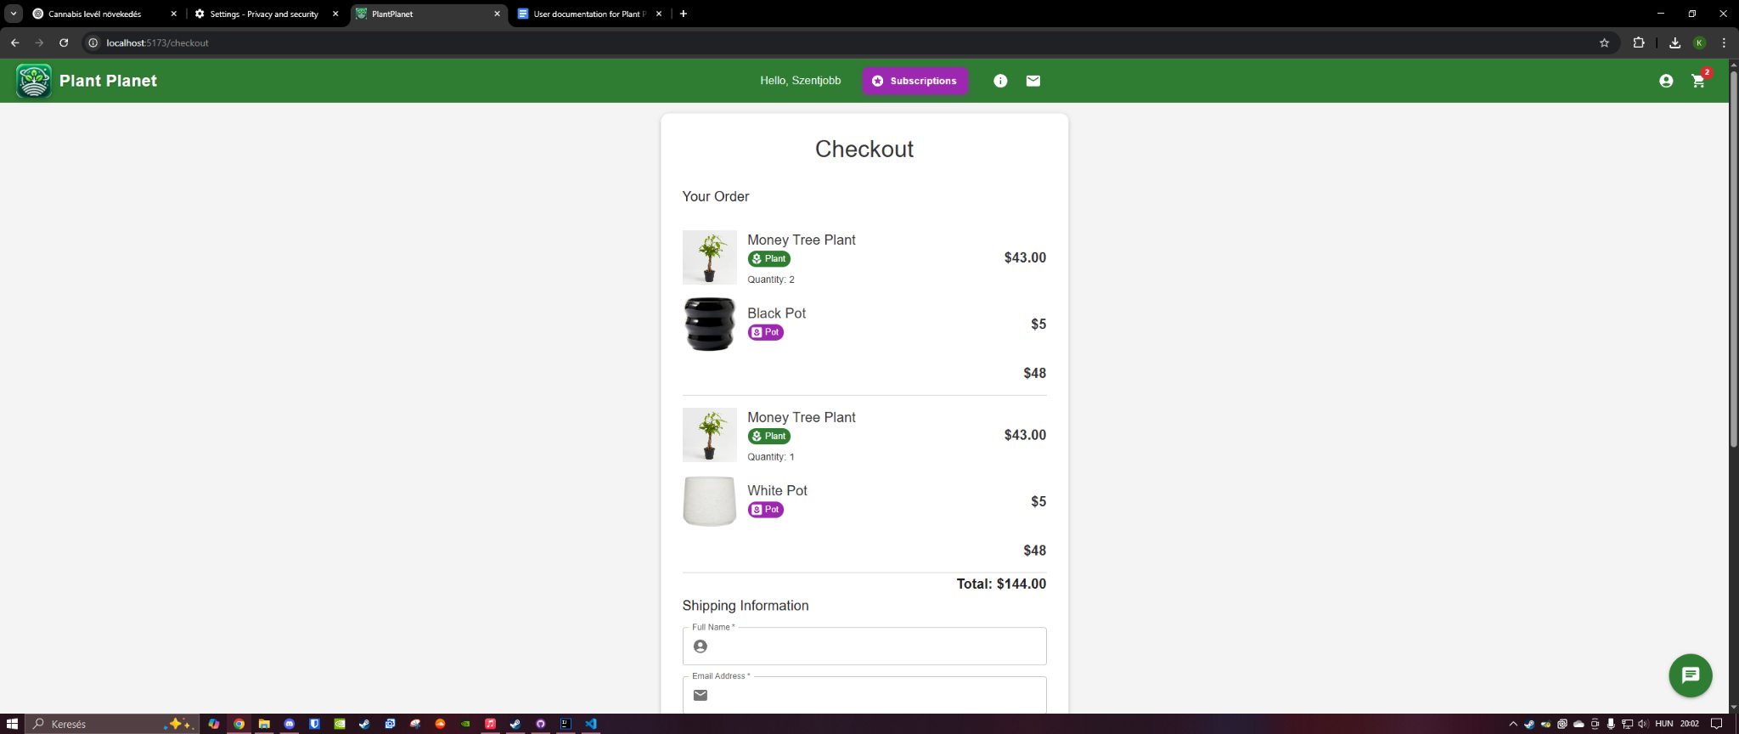

#### **Profile Page(/profile)**

* View and update personal information including:  
  + Name
  + Email
  + Password
  + Profile picture
* View and manage your active subscriptions.
* Cancel a subscription or log out from this page.  
  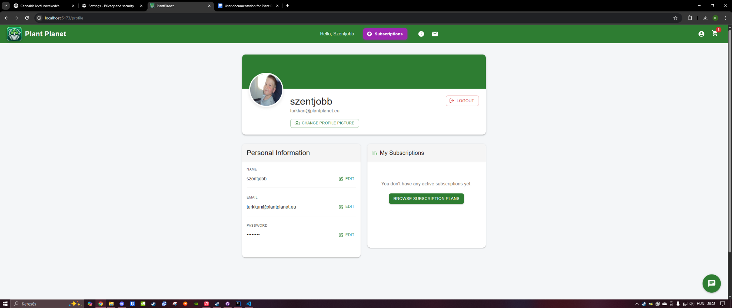

#### **Contact Us(/contact)**

* Send messages to the support team via email form.  
  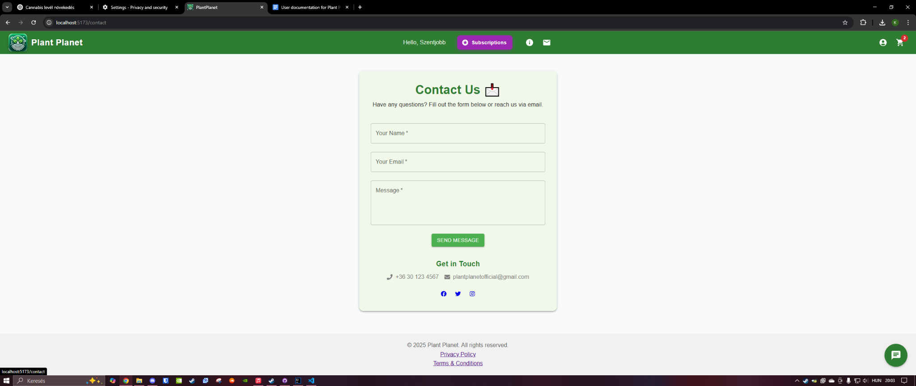

#### **About Us(/about)**

* Learn more about the website and the development team behind it.  
  A képen szöveg, képernyőkép, szoftver, Webhely látható

  Előfordulhat, hogy a mesterséges intelligencia által létrehozott tartalom helytelen.

## **Special Features**

### **Smart Subscriptions**

The **Plant Care Guru** plan provides personalized plant care tips via monthly emails. If a purchased plant has a re-potting period (e.g., one year), subscribers will receive a **free pot** just in time, along with relevant accessories and advice.

### **Support Bot**

Available on all pages (bottom-right corner), the AI-powered **support bot** helps answer basic questions such as:

* Subscription information
* Order tracking
* General site navigation

## **Account & Notifications**

### **Logging In**

You must be logged in to make purchases or subscribe to a plan. Browsing the site does not require login.

### **Email Notifications**

Users will receive email confirmations for:

* Orders placed
* Subscription updates
* Personalized plant care tips (if subscribed to Plant Care Guru)

## **Troubleshooting & Help**

If you encounter any issues or have questions, we recommend:

* Using the **support bot**
* Visiting the **Contact Us** page and submitting a request